**Independent sample T test between year and purchase expense**

Ho = The purchase expense in 2020 is greater than and equal to purchase expense in 2019

H1 = The purchase expense in 2020 is less than purchase expense in 2019

|  |  |  |  |  |  |
| --- | --- | --- | --- | --- | --- |
| **Group Statistics** | | | | | |
|  | year | N | Mean | Std. Deviation | Std. Error Mean |
| purchase expense | 2019 | 2982 | 16.52 | 23.538 | .431 |
| 2020 | 4169 | 16.87 | 26.559 | .411 |

|  |  |
| --- | --- |
|  | |
| t | df | Sig. (2-tailed) | Mean Difference | Std. Error Difference | 95% Confidence Interval of the Difference | |
| Lower | Upper |
| purchase expense | Equal variances assumed | -.575 | 7149 | .565 | -.349 | .608 | -1.541 | .842 |
| Equal variances not assumed | -.586 | 6830.944 | .558 | -.349 | .596 | -1.517 | .819 |

An independent samples t-test was used to compare the purchase expense of 2019 and 2020. According to group statistics the number of purchases in 2019(N=2982) and in 2020(N=4169). The t-test was statistically significant, with mean score of 2019 (M=16.52, SD=23.538) & for 2020 (M=16.87, SD=26.59). In table it can be observed that, p>.05. Therefore, the null hypothesis is failed to reject. It can be concluded that the purchase expenses in 2020 were greater than the purchase expense in 2019.

**Cross Tabulation performed in between years effects on purchase expense.**

The cross tabulation of year and purchase expense can be observed in bar chart for the comparison of the number of purchases each year.

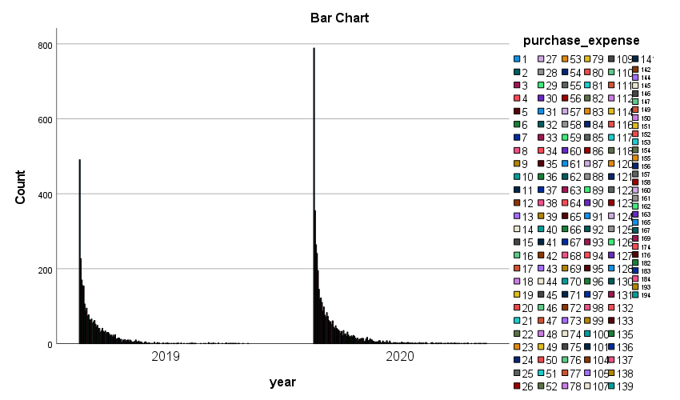

**Top 5 countries with max purchase expenses.**

Do it by yourself. (enough of free lunch)

**Independent sample T test between year and earnings**

Ho = The earnings in 2020 is greater than or equal to earnings in 2019

H1 = The earnings in 2020 is less than the earnings in 2019

|  |  |  |  |  |  |
| --- | --- | --- | --- | --- | --- |
| **Group Statistics** | | | | | |
|  | year | N | Mean | Std. Deviation | Std. Error Mean |
| Earning | 2019 | 5352 | 270776.3249 | 3254492.39758 | 44486.18965 |
| 2020 | 5352 | 288565.0915 | 3467708.82066 | 47400.67986 |

|  |  |
| --- | --- |
|  | |
| T | df | Sig. (2-tailed) | Mean Difference | Std. Error Difference | 95% Confidence Interval of the Difference | |
| Lower | Upper |
| earning | Equal variances assumed | -.274 | 10702 | .784 | -17788.76657 | 65006.50369 | -145213.58390 | 109636.05076 |
| Equal variances not assumed | -.274 | 10659.192 | .784 | -17788.76657 | 65006.50369 | -145213.64179 | 109636.10864 |

An independent samples t-test was used to compare the earnings of 2019 and 2020. According to group statistics the number of earnings in 2019(N=5352) and in 2020(N=5352). The t-test was statistically significant, with mean score. In table it can be observed that, p>.05, Therefore, the null hypothesis is failed to reject. It can be concluded that the earnings in 2020 were greater than or equal the earnings in 2019.

**Independent sample T test between year and no of employees**

Ho = The no of employees in 2020 were less than or equal to no of employees in 2019.

H1 = The no of employees in 2020 were greater than the no of employees in 2019.

|  |  |  |  |  |  |
| --- | --- | --- | --- | --- | --- |
| **Group Statistics** | | | | | |
|  | year | N | Mean | Std. Deviation | Std. Error Mean |
| employess | 2019 | 5352 | 2.46 | 1.978 | .027 |
| 2020 | 5352 | 2.49 | 2.015 | .028 |

|  |  |
| --- | --- |
|  | |
| t | df | Sig. (2-tailed) | Mean Difference | Std. Error Difference | 95% Confidence Interval of the Difference | |
| Lower | Upper |
| employess | Equal variances assumed | -.915 | 10702 | .360 | -.035 | .039 | -.111 | .040 |
| Equal variances not assumed | -.915 | 10698.376 | .360 | -.035 | .039 | -.111 | .040 |

An independent samples t-test was used to compare the no of employees of 2019 and 2020. According to group statistics the number of no of employees in 2019(N=5352) and in 2020(N=5352). The t-test was statistically significant, with mean score. In table it can be observed that, p>.05, Therefore, the null hypothesis is failed to reject. It can be concluded that the no of employees in 2020 were less than or equal to the employees in 2019.

**Pearson Correlation between Earnings and no of Employees**

|  |  |  |  |
| --- | --- | --- | --- |
| **Correlations** | | | |
|  | | earning | employess |
| earning | Pearson Correlation | 1 | .175** |
| Sig. (2-tailed) |  | .001 |
| N | 10704 | 10704 |
| employess | Pearson Correlation | .175** | 1 |
| Sig. (2-tailed) | .001 |  |
| N | 10704 | 10704 |
| **. Correlation is significant at the 0.01 level (2-tailed). | | | |

The relationship between the earnings and no of employees is positive and there is enough evidence to say that there is enough correlation present because the p<.05.